Mozart Requiem & other sacred music
St Michael & All Angels Church, Steventon
Sunday 2nd April 2023, 7 pm
Musical Director: Terry Pearce
Deputy Conductor & Continuo: Debbie West
Organist: Robert Thomas
Guest Soloist Bass: Leslie Macleod-Miller
Tenor: Howard Feather
Alto: Abby Evans
Soprano: Helen Pearce
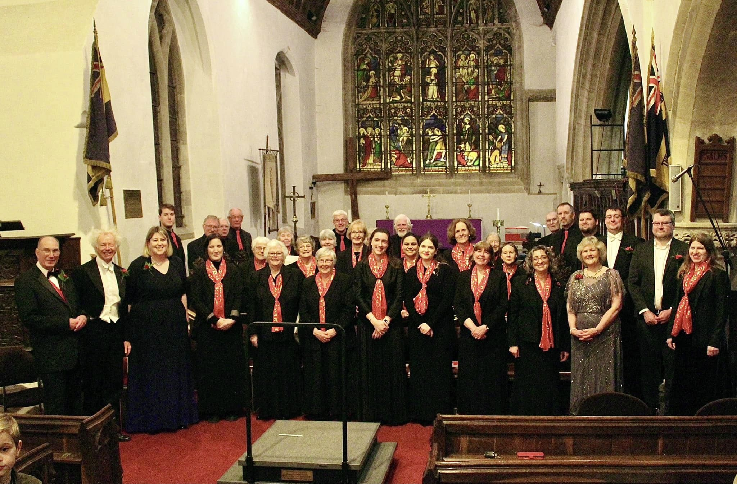
Choir, soloists and musical team (Terry Pearce, Leslie Macleod-Miller and Abby Evans are on the left of the front row; Debbie West, Robert Thomas and Helen Pearce are on the right of the front row with Howard Feather behind them)
The choir opened the concert with a performance of Be Still My Soul, a hymn sung to music from Finlandia by Jean Sibelius. Then came Lord God of Abraham from Felix Mendelssohn’s Elijah sung by guest bass soloist Leslie Macleod-Miller followed by the choir singing the Sweet and Low, a poem by Alfred, Lord Tennyson, set to music by Joseph Barnby. Next a small group (Hazel Cutler, Tiri Jordan, Debbie West, Luke Le Maitre and Bede Beswick) sang an unaccompanied arrangement of the anthem God So Loved the World by John Goss before Leslie Macleod-Miller returned to sing the Victorian song, The Holy City, set to music by Stephen Adams. The first half of the concert concluded with the choir looking forward to the Coronation of King Charles III on 6 May by singing Ralph Vaughan Williams’ rousing setting of The Old Hundredth psalm tune (All People that on Earth do Dwell).
After a short interval came the main piece of the evening: the Requiem in D minor by Wolfgang Amadeus Mozart. The work was unfinished when Mozart died in December 1791 and was completed by Franz Xaver Süssmayer.
Introitus
Kyrie
Dies Irae
Tuba Mirum
Rex Tremendae
Recordare
Confutatis Maledictis
Lacrimosa
Domine Jesu
Hostias
Sanctus
Benedictus
Agnus Dei
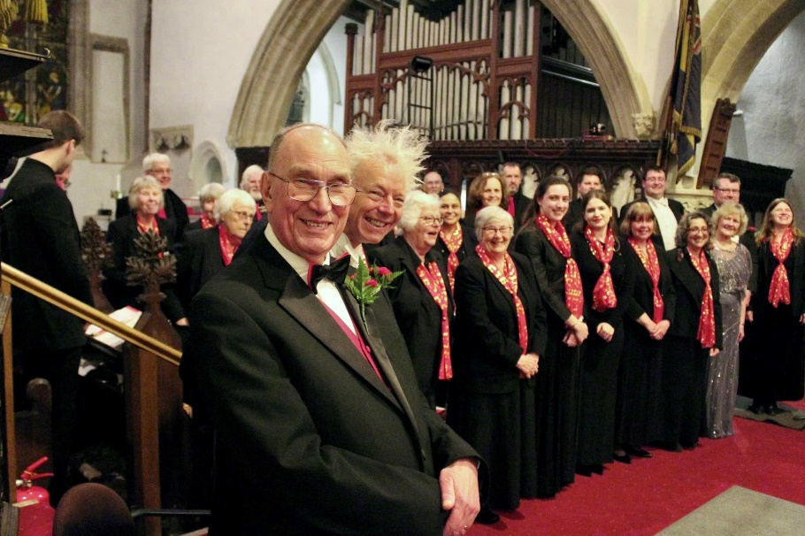
Terry, Leslie and the choir
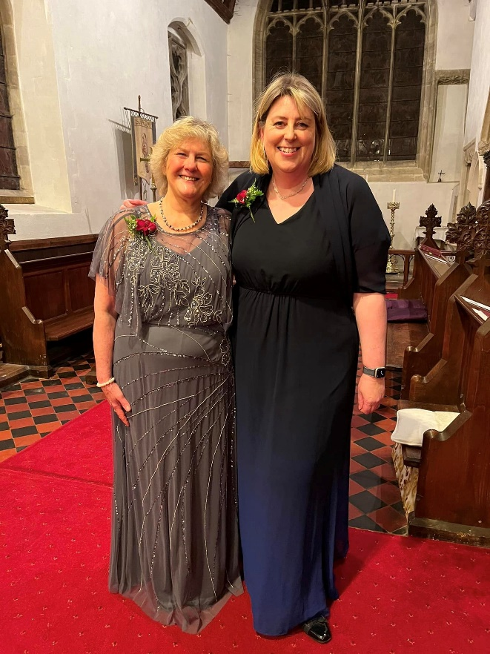
Helen and Abby

